MINI E-COMMERCE FOR VENDORS
@CREATIVITY THINK (9483175986/7019689991)

ABSTRACT:
Mini E-Commerce for Vendors is a web application designed to help small shops, pop-up stores, and event vendors manage products, orders, payments, and customer reviews efficiently. The platform provides seamless product listing, inventory management, order processing, payment tracking, and analytics dashboards. Users can browse products, place orders, pay online, rate and review items, and track their purchases. Administrators can add and manage products, oversee orders and inventory, moderate reviews, and generate analytical dashboards. Built using Django and Django Rest Framework for the backend and React with redux and chart.js for the frontend, the system provides a scalable, secure, and efficient solution for small-scale e-commerce operations..

INTRODUCTION OF THE PROJECT:
Small vendors often struggle to manage products, track orders, and maintain accurate inventory manually. Traditional methods such as spreadsheets or physical registers are prone to errors, delay order processing, and reduce transparency. Mini E-Commerce for Vendors provides a centralized digital platform where product management, order processing, payments, reviews, and analytics are automated. The system enables vendors to operate efficiently, maintain accurate records, and provide a modern shopping experience for their customers while offering administrators detailed insights into business performance..

PROJECT OBJECTIVES:

• Provide a centralized platform for product management
• Allow users to browse products, place orders, and pay online
• Enable customers to rate and review products
• Track inventory and update stock levels in real time
• Provide dashboards with analytics for sales and inventory
• Allow administrators to manage products, orders, and reviews
• Ensure secure and scalable backend APIs for smooth operations
• Generate reports for better decision-making and business insights

PROBLEM OF THE STATEMENT:
Small-scale vendors often lack access to professional e-commerce solutions. Manual inventory management, order tracking, and payment collection cause inefficiencies and errors. There is no easy way to monitor sales performance or customer feedback systematically. Mini E-Commerce for Vendors solves these problems by providing a lightweight, automated, and centralized platform for managing products, orders, payments, inventory, and analytics, improving efficiency and transparency..

MOTIVATION OF THE PROJECT:
• To empower small vendors with a professional e-commerce platform
• To reduce manual errors in order and inventory management
• To simplify payment collection and order processing
• To provide an easy-to-use interface for product browsing and ordering
• To enable administrators to moderate reviews and manage inventory
• To offer sales and inventory insights through dashboard analytics
• To increase operational efficiency and customer satisfaction

BLOCK DAIGRAM OF PROJECT:

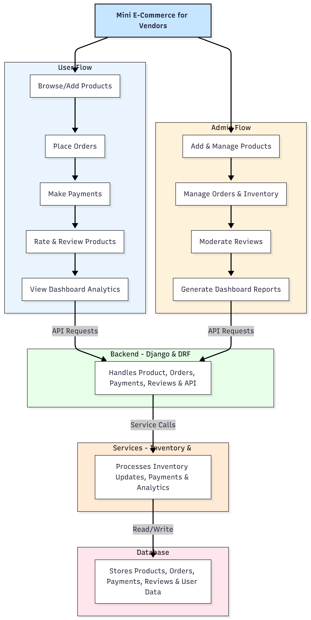

WORKING OF THE PROJECT:
The system allows administrators to add products with details such as name, price, stock, and category. Users can browse the catalog, add products to their cart, place orders, and make online payments. Customers can submit ratings and reviews, which administrators can moderate. Inventory levels are updated automatically, and the system logs all transactions for transparency. Dashboard analytics provide insights on sales, revenue, stock levels, and customer feedback. The backend manages APIs, inventory validation, payment processing, and data storage, ensuring smooth, secure, and real-time operations..

SOFTWARE REQUIREMENT:
- Backend:
  - Python 3.x
  - Django
  - Django REST Framework
  - SQLite/PostgreSQL
- Frontend:
  - Node.js and npm
  - React.js
  - Axios
- Development Tools:
  - Visual Studio Code
  - Postman (for testing APIs)
  - Git/GitHub (for version control)
- Server/Deployment (Optional):
  - Gunicorn, Nginx, or Heroku/AWS for hosting

ADVANTAGES OF THE PROJECT:

• Centralized product, order, and inventory management
• Automated payment and booking processing
• Customer feedback through ratings and reviews
• Dashboard analytics for business insights
• Reduces errors caused by manual operations
• Improves transparency and efficiency for vendors
• Scalable for multiple small vendors or pop-up stores
• Enhances customer experience and satisfaction

APPLICATIONS OF THE PROJECT:
• Small shops and retail vendors
• Pop-up store operations
• Event-based sales management
• Home-based businesses and micro-vendors
• Temporary markets or exhibitions
• Small-scale e-commerce setups

REFERENCES:

- Django REST Framework Documentation — Django Software Foundation. Django Documentation. Available: https://docs.djangoproject.com/
- Django REST Framework. DRF Documentation. Available: https://www.django-rest-framework.org/
- React. React Official Documentation. Available: https://reactjs.org/docs/getting-started.html
- Redux. Redux Documentation. Available: https://redux.js.org/introduction/getting-started
- PostgreSQL Global Development Group. PostgreSQL Documentation. Available: https://www.postgresql.org/docs/
- MySQL. MySQL Reference Manual. Available: https://dev.mysql.com/doc/
- Git. Git Documentation. Available: https://git-scm.com/doc
- Node.js. Node.js Documentation. Available: https://nodejs.org/en/docs/
- Axios. Axios Documentation. Available: https://axios-http.com/docs/intro
- Socket.io Documentation – https://socket.io/docs/

